Open Embedded Development

Requirements
Install necessary packages to run OpenEmbedded and Bitbake:
sudo apt-get install git-core build-essential help2man diffstat texi2html texinfo cvs subversion gawk chrpath
Use Dash instead of Ubuntu’s default Bash:
sudo dpkg-reconfigure dash

Bitbake
Delete the Open embedded configuration file, if it already exists:
rm –r .oe/
Rerun the beagleboard configuration:
sh angstrom-setup-scripts/oebb.sh config beagleboard
Download / update OpenEmbedded:
sh angstrom-setup-scripts/oebb.sh update
Build base image for beagle board:
source ~/.oe/environment
bitbake base-image
Bitbake can be stopped. It will resume later on and just build new packages. The whole procedure can take up to 7 hours. Once down, you can rebuild the image in about 10 minutes.

If some packages (makeinfo, chrpat) are still missing …
apt-file search makeinfo > reveals that makeinfo is part of texinfo
Install apt-file and update the repository list.
Make info is available in texinfo:
sudo apt-get apt-file
sudo apt-file update

Beagleboard
Connect the beagleboard with the USB cable to the computer running Linux or and Virtual machine using Linux. Assign the USB Network to the virtual machine and configure it in Linux using the console or a network GUI.

Ofono
Install ofono and ofono-phonesim and adjust /etc/ofono/moden.conf and restart with
/etc/init.d/ofono restart
List all the files in the ofono-phonesim package
dpkg – L ofono-phonesim
Copy the configuration file to the angstrom folder
cp /usr/share/doc/ofono-phonesim/default.xml.gz .
Start ofono-phonesim
ofono-phonesim –p 12345 –gui default.xml
Open another terminal and enter which opens the Phonesim application
dbus-send --print-reply --system --dest=org.ofono /phonesim org.ofono.Modem.SetProperty string:"Powered" variant:boolean:"true"
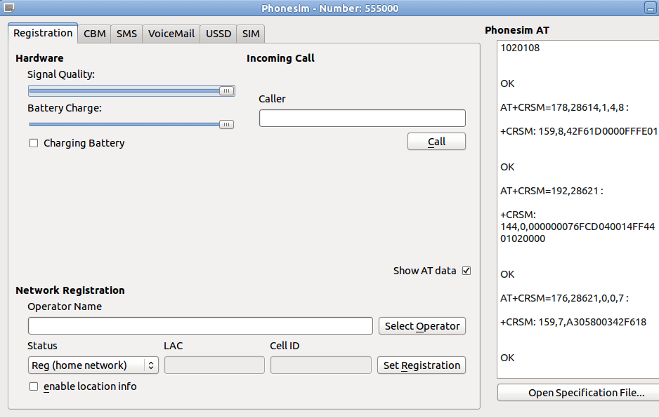

Dial a number:
dbus-send --print-reply --system --dest=org.ofono /phonesim org.ofono.VoiceCallManager.Dial string:"012345" string:"default"

D-feed
Install d-feet the D-Bus debugger and create a System Bus to check the org.fono connection:
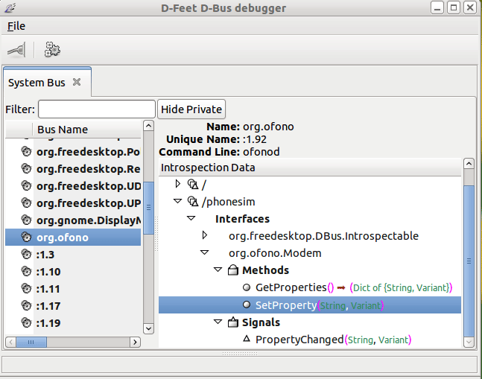

Create CPP files out of the XML files
See Group-Project.pdf page 14 and following.

1.) Power up the “phone”:
sudo dbus-send --print-reply --system --dest=org.ofono /phonesim org.ofono.Modem.SetProperty string:"Powered" variant:boolean:"true"

2.) Enter:
dbus-send --print-reply --system --dest=org.ofono /phonesim org.freedesktop.DBus.Introspectable.Introspect > fileName

